
Component Model
Generate virtual ray laser data in Point Cloud
Robotic Cognition System for Wheelchair
Unicamp

Table of Contents
1 Purpose of this Document 3
2 Component Design 4
2.1 Purpose 4
2.2 System Diagram 4
2.3 Component Input 4
2.4 Component Output 4
2.5 Component Processing 4
3 Component Execution 6
4 References 8

Document Information
Project Name: | Robotic Cognition System for Wheelchair
Prepared By: | Tarcísio Franco de Carvalho | Document Version No: | 1.0
Title: | Component Model – Move to the target | Document Version Date: | 05/Jan/2021
Reviewed By: |  | Review Date:
Distribution List
From | Date | Email
Eric Rhomer |  | rohmer@unicamp.br

Acronyms
Acronym | Description
ROS | Robot Operational System
PCL | Point Cloud Library

Document Version History
Version  Number | Version  Date | Revised By | Description | Filename

Purpose of this Document
Define how the related component works and its relation in the main system.

Component Design

Purpose
This component is responsible to generate a ray laser in the point cloud that will simulate a real laser based on the pan and tilt data.

System Diagram

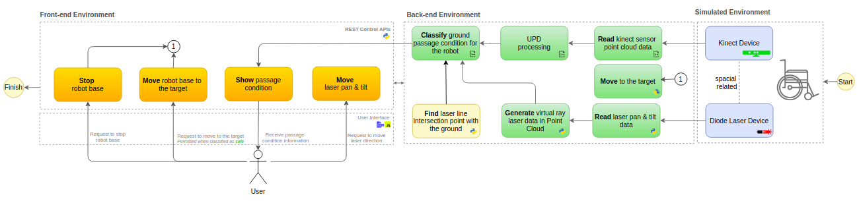

Component Input
This component expects the following input data:
- Pan data
- Tilt data
- Origin X, Y, Z position

Component Output
This component expects the following output data:
- Point cloud data containing a ray laser simulated

Component Processing
These are the main processing steps of this component:
- Calculate the target X, Y, Z point based on the origin point and the pan and tilt data
- Generate a point cloud data containing a line from the origin (X, Y, Z) to the calculated target (X, Y, Z)

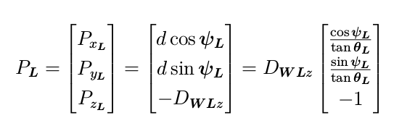

x = radius .* cos(elevation) .* cos(azimuth);
y = radius .* cos(elevation) .* sin(azimuth);
z = radius .* sin(elevation);
zCoord = nearClippingPlane + depthAmplitude.*depthValue;
xCoord = tan(xAngle).*zCoord;
yCoord = tan(yAngle).*zCoord;
r=find(zCoord >0);
pointcloud = [xCoord(r) yCoord(r) zCoord(r)];

References

- Transform
  - Draw 2D point cloud objects: https://pointclouds.org/documentation/classpcl_1_1visualization_1_1_p_c_l_painter2_d.html#details
  - Point Cloud Visualization: https://www.programmersought.com/article/51154789028/
  - PCL Painter 2D: https://gitlab.safeai.ai/serge/pcl/-/blob/pcl-1.7.2rc1/visualization/src/pcl_painter2D.cpp
  - Point Cloud Line Option:
    - https://stackoverflow.com/questions/14797673/find-points-on-the-line-in-point-cloud
    - https://github.com/jimjibone/robotarm/blob/master/Kinect%20Object%20Detector/Object%20Detection/JRConvexHull/JRConvexHull.cpp#L43
  - RANSAC
    - https://pointclouds.org/documentation/tutorials/random_sample_consensus.html
    - https://medium.com/@ajithraj_gangadharan/3d-ransac-algorithm-for-lidar-pcd-segmentation-315d2a51351
    - https://stackoverflow.com/questions/38754668/plane-fitting-in-a-3d-point-cloud
  - Math
    - https://www.geeksforgeeks.org/program-find-line-passing-2-points/
    - https://www.youtube.com/watch?v=JlRagTNGBF0

- Book - Learning Robotics using Python – Second Edition – By Lentin Joseph

